**­­**

**REPUBLIQUE DU CAMEROON**

**PAIX-Travail-Patrie**

**MINISTRE DE L’ENSEIGNEMENT SUPERIEUR**

**FACULTE D’INGINERIE**

**ET TECHGNOLOGIE**

**REPUBLIC OF CAMEROON**

**Peace-Work-Fatherland**

**MINISTER OF HIGHER EDUCATION**

**FACULTY OF ENGINEERING**

**AND TECHNOLOGY**

# **UI Design and Implementation Report for Archival and Retrieval of Missing Object App**

**COURSE TITLE: INTERNET PROGRAMMING AND MOBILE PROGRAMMING**

**COURSE CODE: 440**

**GROUP MEMBERS**

|  |  |
| --- | --- |
| **Name** | **Matricule** |
| NSEM CONFIDENT NJOCK | FE21A285 |
| NZEMTEJUH SYLVANUS | FE21A296 |
| NKWENKAM JENNIFER | FE21A279 |
| VTALAH DE GERAUD | FE21A329 |
| OLETIA AJONGAKUE SYNCLAIR | FE21A190 |

**COURSE FACILITATOR:** DR. Nkemeni Valery

Table of Contents

**UI Design and Implementation Report for Archival and Retrieval of Missing Object App** 1

1. INTRODUCTION 3

2. UI Design 3

2.1. Design Principles 3

2.2. Wireframes and Mockups 3

2.3. User Flow 3

2.4. Design Tools 3

2.5. Color Scheme and Typography 4

3. UI Implementation 4

3.1. Frameworks and Libraries 4

3.2. Components and Widgets 4

3.3. Responsive Design 4

3.4. Accessibility Features 4

4. Challenges and Solutions 4

4.1. challenges 5

4.2. Solutions 5

5. Conclusion 5

6. References 5

# INTRODUCTION

The purpose of this report is to document the design and implementation of the User Interface (UI) for an archival and retrieval of missing objects app. The app allows users to report and search for lost and found items, enhancing the efficiency and effectiveness of reuniting lost items with their owners.

# UI Design

## Design Principles

The design of the app adheres to the following principles:

* **Usability**: The app is designed to be intuitive and easy to navigate for all users.
* **Accessibility**: Features are included to ensure the app is accessible to users with disabilities.
* **Responsiveness**:The UI adapts to various screen sizes and orientations.

## Wireframes and Mockups

Wireframes and mockups were created using Figma to visualize the app's layout and design. Each screen’s purpose and layout were carefully considered.

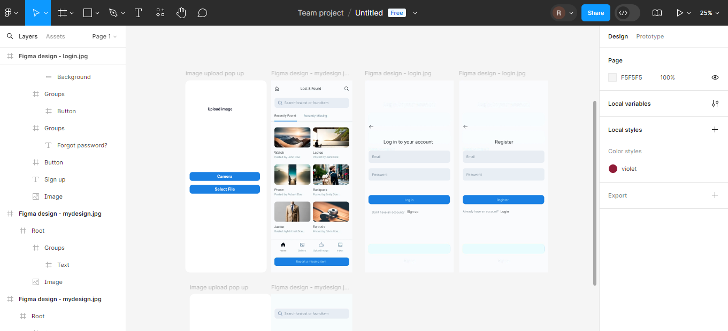

## User Flow

The user flow describes how users navigate through the app:

* **Home Screen**: Users can search for lost or found items.
* **Tabs**: Recently Found and Recently Missing items are categorized.
* **Detail Screens**: Clicking on an item provides more details and contact information.
* **Reporting**: Users can report a missing item via a dedicated button.

## 2.4. Design Tools

* **Figma**: Used for designing wireframes and mockups.
* **Android Studio**: Used for developing the UI with XML.

## 2.5. Color Scheme and Typography

* **Color Scheme**: The app uses a clean and modern color scheme, primarily using blue and white for a professional and trustworthy appearance.
* **Typography**: Simple and readable fonts were selected to ensure clarity and legibility.

# UI Implementation

## 3.1. Frameworks and Libraries

* **Android Studio**: The primary Integrated Development Environment (IDE) used.
* **XML**: Used for designing the UI layout.
* **Java**: Intended for backend implementation.

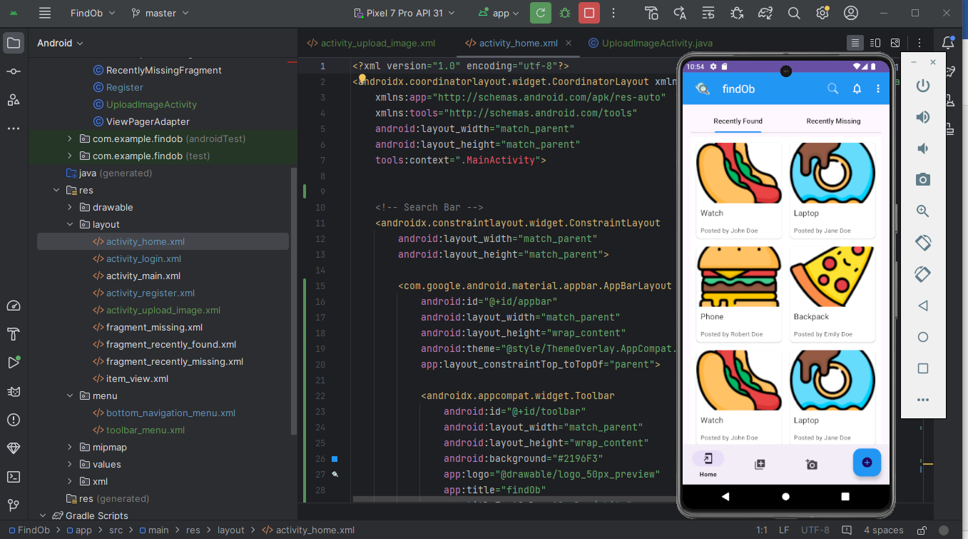

## 3.2. Components and Widgets

* **Search Bar:** Allows users to search for lost or found items.
* **Tabs**: Separate tabs for Recently Found and Recently Missing items.
* **Item Cards:** Display items with images and descriptions.
* **Navigation Bar:** Provides quick access to Home, Gallery, Upload Image, and Inbox.
* **Button**: "Report a missing item" button for users to report lost items.

## 3.3. Responsive Design

The app's layout adapts to various screen sizes and orientations to ensure a seamless user experience across different devices.

### 3.4. Accessibility Features

Accessibility features include:

* **Text Alternatives**: For images to assist visually impaired users.
* **Color Contrast**: Ensures text is readable for users with visual impairments.

## Challenges and Solutions

### challenges

* **Design Consistency**: Ensuring a consistent design across all screens was challenging but resolved through iterative testing and feedback.
* **Responsive Design**: Adapting the UI for different screen sizes required careful planning and implementation.

### 4.2. Solutions

* **Iterative Design Process**: Regular reviews and updates helped maintain design consistency.
* **Flexible Layouts**: Using flexible layouts in XML ensured the app adapts well to different devices.

# Conclusion

This report documents the UI design and implementation process for the archival and retrieval of missing objects app. The design prioritizes usability, accessibility, and responsiveness to provide an efficient and user-friendly experience.

# References

Android Developer Documentation:

Figma Design Resources: